**Assignment 2**

1. Why we need packages in java?
   1. Group related classes in the similar topic.
   2. Prevent name conflict.
2. What is the default imported package?

Java.lang package

1. What is Class? What is Object?

A Class is like an object constructor (not the constructor in class), or a "blueprint" for creating objects. An Object is an instance of a class.

1. Why we need constructor?

The constructor is called when an object of a class is created. It can be used to set initial values for object attributes. if you do not create a class constructor yourself, Java creates one for you. The purpose is to initializes the newly created object before it is used.

1. What is the default value of local variable? What is the default value of instance variable?

The default value of local variable: NULL

The default value of instance variable: 0

1. What is garbage collection?

The JVM recycle the memory automatically by garbage collection. The default GC in Java is parallel GC, which minor GC (more frequently than major GC)) for the young generation and major GC for old generation. The pic show below.

1. The protected data can be accessed by subclasses or same package. True or false?

True, the modifier table shows below.

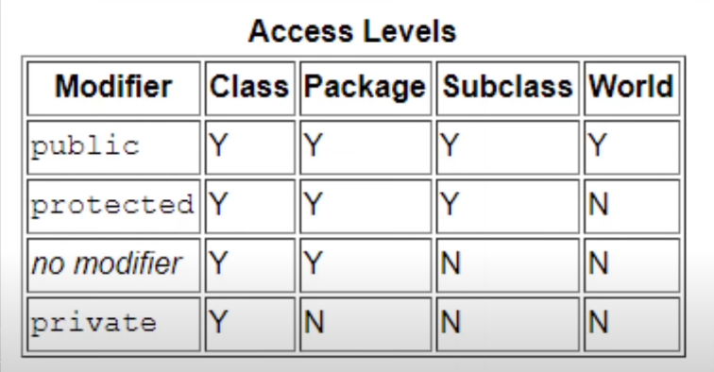

1. What is immutable class?

Once you initiate an object by immutable class, you can’t change its content anymore.

1. What’s the difference between “==” and equals method?

The “==“ compare the address locations, equals method compare the content of each object.

1. What is wrapper class?

A class which the object wraps or contains primitive data types. Another word, we can wrap a primitive value into a wrapper class object.

1. What is autoboxing?

The primitive data type converts to the corresponding wrapper class, we call it autoboxing. Reverse process, we call it unboxing. The corresponding table shows below.

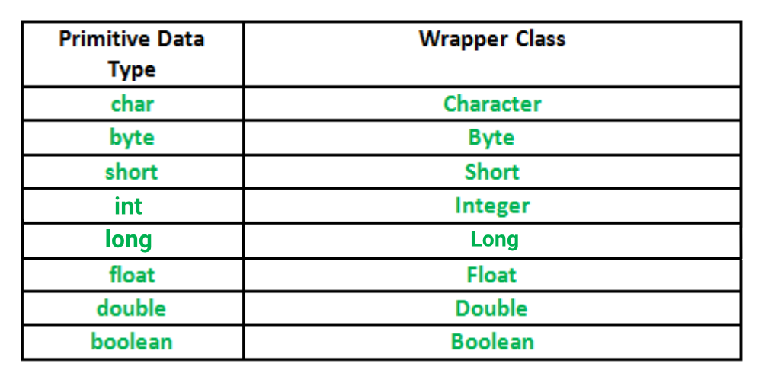

1. StringBuilder is threadsafe but slower than StringBuffer, true or false?

False, StringBuilder is no thread safe but faster than StringBuffer.

1. Constructor can be inherited, true or false?

False, constructor can’t be inherited.

1. How to call a super class’s constructor?

We use super() to call.

1. Which class is the super class of all classes?

Object class is the super class of all classes.

1. Create a program to count how many files/folders are there inside one folder.

* the count method should take a parameter called Criteria like this: count(Criteria criteria){}
* For Criteria class, multiple conditions should be included such as: folder path, includeSubFolder or not, the extension of the file be counted and so on.
* Optional: Take the input from keyboard.
* Take care of the invalid inputs. Exception handling.
* Get proper result displayed.  
  ”There are XXX file(s) and XXX folder(s) inside folder XXX with extension XXX.” or something user friendly.

Output:

